Report 1: Exploration, Data Visualization, Preprocessing and Feature Engineering

1. Introduction to the Project

Context
This project investigates road accident severity in France using open government datasets. The goal is to understand environmental, temporal, and geographic factors contributing to accident outcomes, and to prepare the data for predictive modeling.

Business Integration
- Technical: The project integrates multiple relational datasets (accident characteristics, location, vehicles, users) using a shared key (Num_Acc). It builds a unified accident-level view with engineered features for modeling.
- Economic: Road accidents impose significant costs on healthcare, infrastructure, and insurance. Early detection of severity patterns can guide resource allocation and policy.
- Scientific: The project explores correlations between lighting, weather, time, and location with accident severity. It also addresses challenges like missing geolocation and class imbalance.

2. Objectives
- Build a clean, structured accident-level dataset from raw relational files
- Explore temporal, spatial, and environmental patterns
- Engineer interpretable features for modeling severity
- Prepare the data for multiclass and binary classification pipelines
This phase focuses on data understanding and preprocessing, not modeling.

3. Understanding and Manipulation of Data

Framework
- Datasets used: caract, places, vehicles, users, holidays
- Source: French government open data
- Volume: ~840,000 accident records (2005–2016)

Relevance
- Target variable: grav (severity) from users.csv
- Key features: lighting, weather, collision type, time of day, season, geolocation
- Limitations:
  - Heavy missingness in latitude/longitude
  - Inconsistent formats (e.g., hourminute, GPS codes)
  - Sparse address and GPS metadata

Preprocessing DataFrames

4.1 CARACT (Characteristics) Dataframe - Auditing, Cleaning and Preprocessing

Column Renaming
Renamed columns in caract for clarity and consistency:
- Num_Acc → accident_id, hrmn → hourminute, lum → lighting, etc.

Mapping and Labeling
Applied dictionaries to convert coded values into readable labels:
- lighting_label, urban_label, intersection_label, weather_label, collision_label, gps_label

Geolocation Normalization
- Cleaned and converted latitude and longitude from string to float
- Created scaled candidates (raw, /1e5, /1e6)
- Selected valid values within France’s geographic bounds
- Created latitude_num, longitude_num, and valid_geo flag
- Result: ~220,000 rows with valid geolocation

Temporal Features
- Expanded 2-digit year codes to full years
- Parsed hourminute into hour, minute, time_hhmm
- Derived time_of_day, is_weekend, and season from date components

Final Schema
After cleaning and feature engineering, the caract dataframe includes:
- 20 columns
- 839,985 rows
- Fully typed: Int64, float64, category, bool, datetime
- No duplicate accident_id
- Heavy missingness in geolocation, minimal elsewhere

Visualizations and Statistics
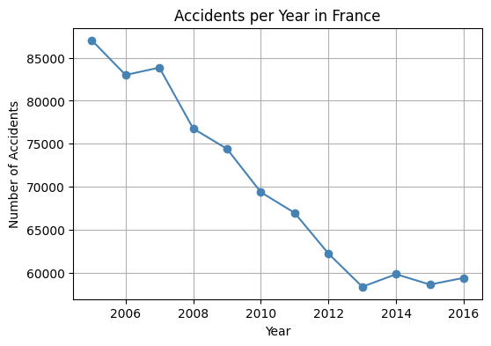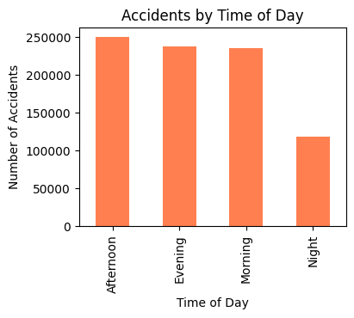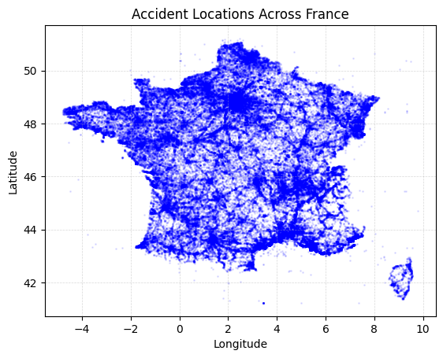

Accidents per Year
- Line plot shows a steady decline from 2005 to 2013
- Reflects improved road safety and policy interventions

Accidents by Time of Day
- Bar chart shows peaks in Afternoon and Evening
- Suggests rush-hour vulnerability

Spatial Distribution
- Scatter plot of valid geolocations
- Dense clusters around Paris, Lyon, Marseille, Lille
- Confirms urban concentration of accidents

Accidents by Weather and Lighting
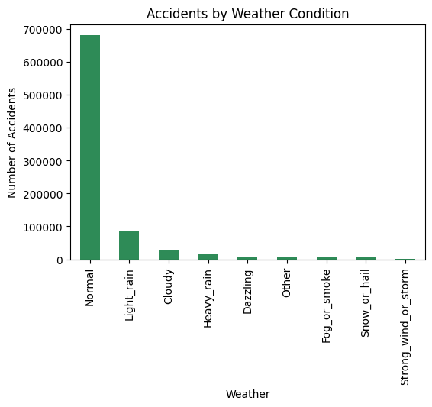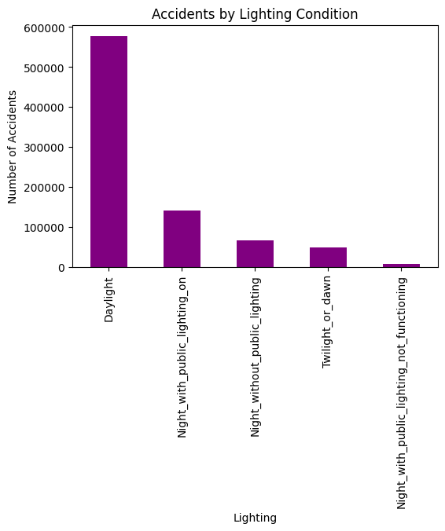
- Most accidents occur in normal weather and daylight
- Adverse conditions (fog, night, rain) are less frequent but may correlate with severity.

Cleaning Summary:
Dropped raw columns before merging:
- Removed: hourminute, raw codes for lighting, urban area, intersection, weather, collision, GPS, address, latitude, longitude, department
- Retained: engineered and labeled features only
Final shape: 839,985 rows × 20 columns

4.2 PLACES Dataframe — Auditing, Cleaning and Preprocessing

Overview
The places dataset describes the physical and infrastructural characteristics of the accident location.
It contains 839,985 rows and originally 27 columns, all linked to accident_id.

Initial Audit
- Key numeric fields: num_lanes, pedestrian_crossing_width, road_width
- Key coded categorical fields: road category, traffic regime, road profile, layout, surface condition, infrastructure, situation, school zone
- Missing values mainly in:
  - pedestrian_crossing_width (~9.5k)
  - road_width (~8.2k)
  - num_lanes (~1.7k)
- No duplicate accident_id

Column Renaming
Raw coded columns were renamed for clarity (e.g., catr → road_category, circ → traffic_regime, surf → surface_condition).
This standardizes naming across datasets and improves readability.

Mapping Codes to Labels
All coded variables were translated into human-readable labels using mapping dictionaries:
Examples:
- Road category: Highway, National road, Departmental road, Communal way, etc.
- Traffic regime: One-way, Bidirectional, Separated carriageways
- Surface condition: Normal, Wet, Puddles, Flooded, Snow, Icy, Oil
- Infrastructure: Tunnel, Bridge, Interchange, Railway, Roundabout
- Situation: On road, On verge, On sidewalk, On bike path
- School zone: Near school, Not near school, Unknown
All missing or unmapped values were set to "Unknown".

Verification
Side-by-side checks confirmed:
- All codes correctly mapped
- No unexpected categories
- NaN values handled consistently

Dropping Raw Code Columns
After creating label columns, redundant coded fields were removed to simplify the dataset.

Final Columns (13 total)
accident_id,num_lanes,pedestrian_crossing_width,road_width,road_category_label,traffic,regime_label,reserved_lane_label,road_profile_label,road_layout_label,surface_condition_label,infrastructure_label,situation_label,school_zone_label

PLACES Visualizations
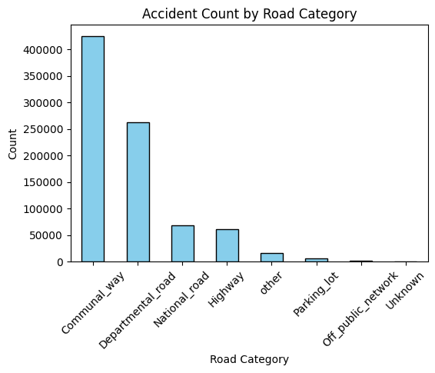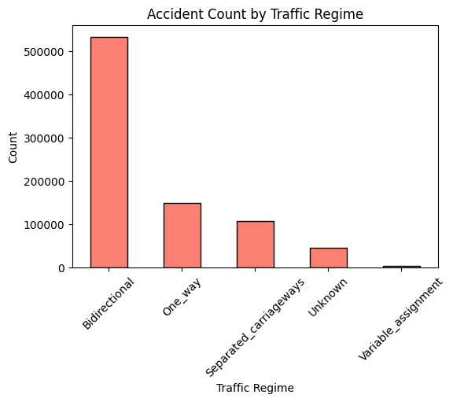
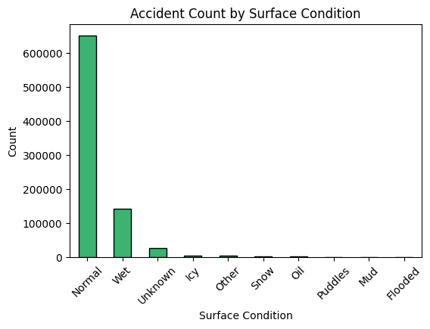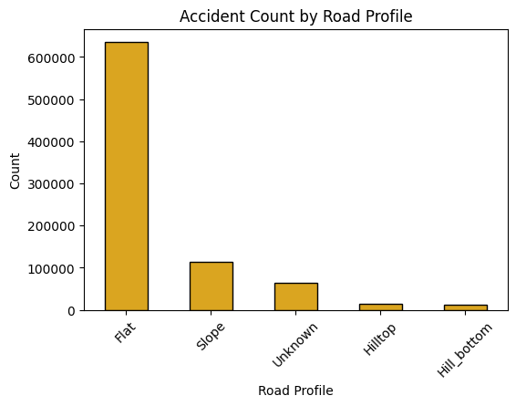

Road Category

- Most accidents occur on communal and departmental roads, reflecting high traffic density and complex navigation.
- Highways show fewer accidents, suggesting better control but potentially higher severity.
- Minimal unknowns — strong data quality.

Traffic Regime

- Bidirectional roads dominate accident counts, likely due to lack of separation and unpredictable maneuvers.
- One-way and separated carriageways show lower risk, supporting investment in controlled traffic flow.

3. Surface Condition
- Majority of accidents happen on normal, dry roads, not extreme conditions.
- Wet surfaces still pose risk, especially during seasonal transitions.
- Reinforces that driver behavior and road design matter more than weather alone.

4. Road Profile
- Flat terrain is most common in accidents, but not necessarily most severe.
- Slopes deserve attention for signage and speed control.
- Hilltop and hill bottom roads are rare but may need targeted safety planning.

4.3 USERS Dataframe

Overview
The users dataframe contains 1.87 million records detailing individuals involved in accidents, including drivers, passengers, and pedestrians.
It links to accident_id and includes demographic, behavioral, and injury-related attributes.

Cleaning and Labeling
- Renamed raw columns for clarity (e.g., grav → injury_severity, secu → safety_equipment)
- Mapped coded fields to readable labels:
  - User category, injury severity, seat position, journey purpose
  - Pedestrian context: location, action, state
  - Safety equipment split into:
    - safety_equipment_type (e.g., Seat belt, Helmet)
    - safety_equipment_usage (Used, Not used, Undetermined)
- Filled all unmapped values with "Unknown"

Missingness
- Most missing: seat_position (~100k), safety_equipment (~43k), birth_year (~2.3k)
- Pedestrian fields have minor gaps
- No missing values in accident_id, injury_severity, or user_category

Distributions
- Sex: 67% Male, 33% Female
- User Category: 75% Drivers, 17% Passengers, 8% Pedestrians
- Injury Severity: 41% Uninjured, 36% Slight, 21% Hospitalized, 3% Killed
- Journey Purpose: Leisure dominates, followed by Unknown and Home–Work
- Safety Equipment Usage: 75% Used, 15% Undetermined, 5% Not used

Visual Insights
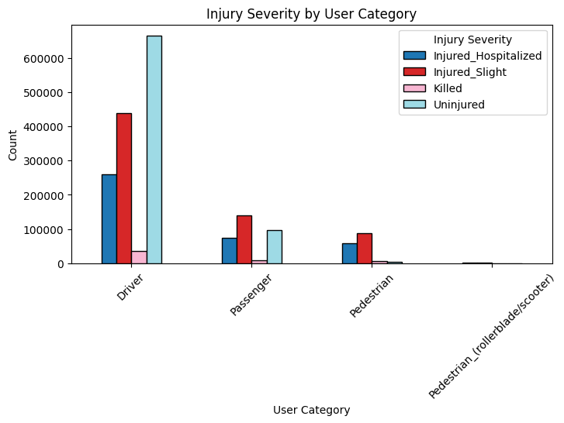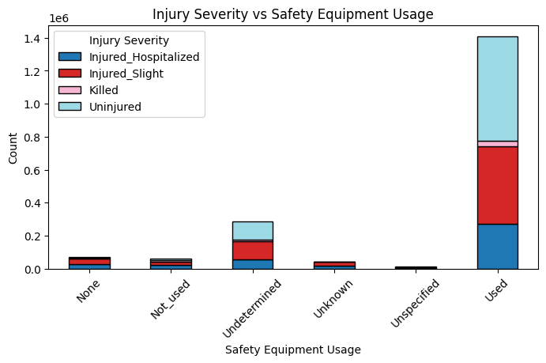

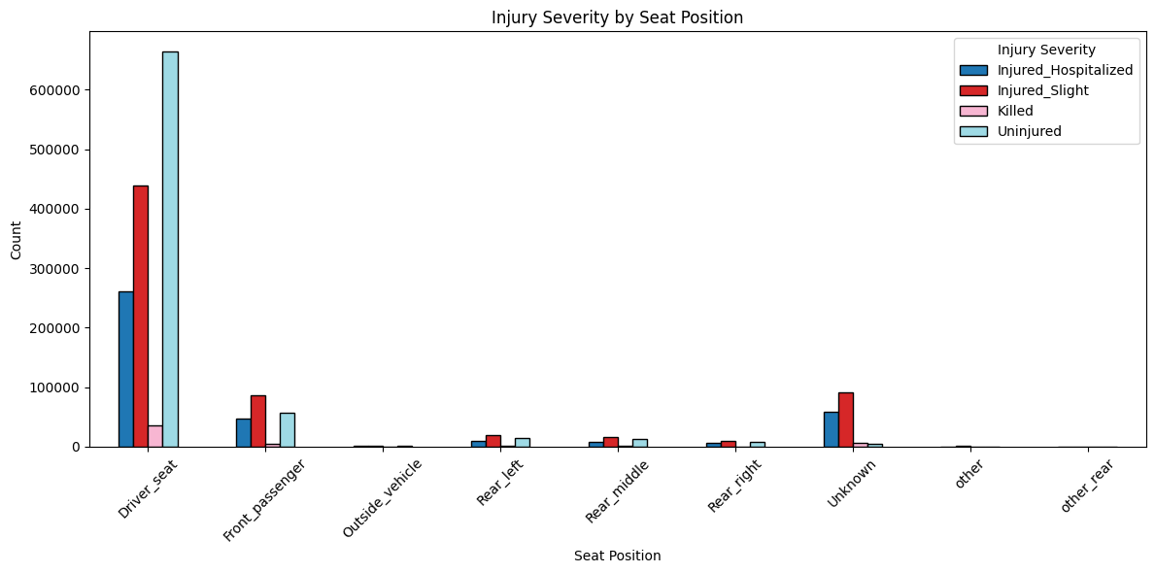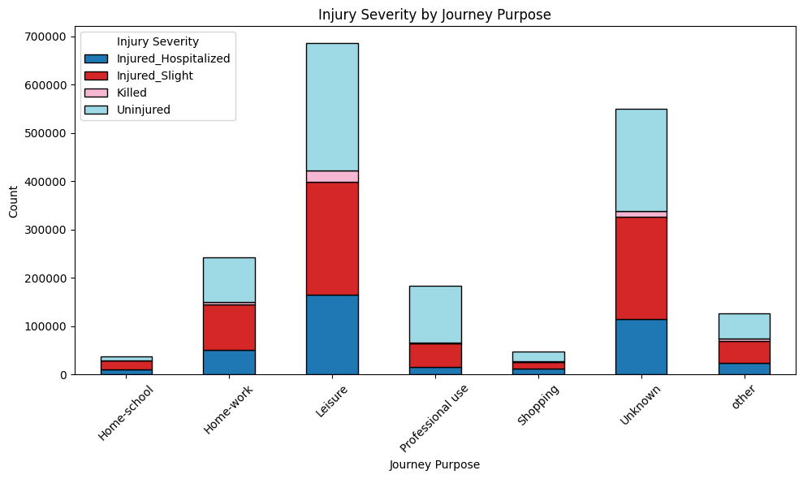

1. Injury Severity by User Category
- Drivers dominate in volume and show high survival rates
- Pedestrians have fewer cases but higher fatality and hospitalization rates
- Passengers show moderate risk

2. Injury Severity vs Safety Equipment Usage
- Used equipment correlates with lower severity
- Not used and Undetermined groups show higher risk
- Reinforces the protective role of safety gear

3. Injury Severity by Seat Position
- Driver seat is most exposed
- Rear seats show safer profiles
- Outside vehicle and Unknown categories need careful modeling treatment

4. Injury Severity by Journey Purpose
- Leisure trips dominate accident volume
- Professional and Home–Work journeys show higher severity proportions
- Unknowns are frequent and may dilute interpretability

Summary

Final Columns
After mapping and labeling all coded fields, the raw numeric columns were removed to keep only interpretable, analysis-ready variables for merging and visualization.

Dropped columns
- Raw coded fields no longer needed after mapping:
  - seat_position, user_category, injury_severity, sex, journey_purpose
  - safety_equipment, pedestrian_location, pedestrian_action, pedestrian_state

Final USERS columns (13 total)
accident_id, birth_year, vehicle_id, sex_label, user_category_label, injury_severity_label, seat_position_label, journey_purpose_label, pedestrian_location_label, pedestrian_action_label, pedestrian_state_label, safety_equipment_type, safety_equipment_usage

Final shape - 1,876,005 rows × 13 columns

4.4 VEHICLES Dataframe —

Overview
The vehicles dataframe contains 1.43 million records detailing vehicle involvement in accidents.
It includes type, maneuver, impact point, and obstacle interaction, linked via accident_id and vehicle_id.

Cleaning and Labeling
- Renamed raw columns for clarity (e.g., catv → vehicle_category, manv → manoeuvre)
- Mapped coded fields to readable labels:
  - Vehicle category grouped into 8 types (e.g., Car, Motorcycle, Cycle, Utility)
  - Manoeuvre reduced to 12 categories (e.g., Turning, Lane change, Emergency)
  - Impact point, traffic direction, obstacles all simplified for analysis
- Filled all unmapped values with "Unknown"
- Grouped occupants into "0–10" and "10+" for modeling
- Dropped raw columns post-labeling to streamline merge

Missingness
- Minor gaps in:
  - traffic_direction (~72)
  - fixed_obstacle (~762)
  - mobile_obstacle (~601)
  - impact_point (~229)
  - manoeuvre (~306)
- No duplicates in accident_id + vehicle_id

Visual Insights
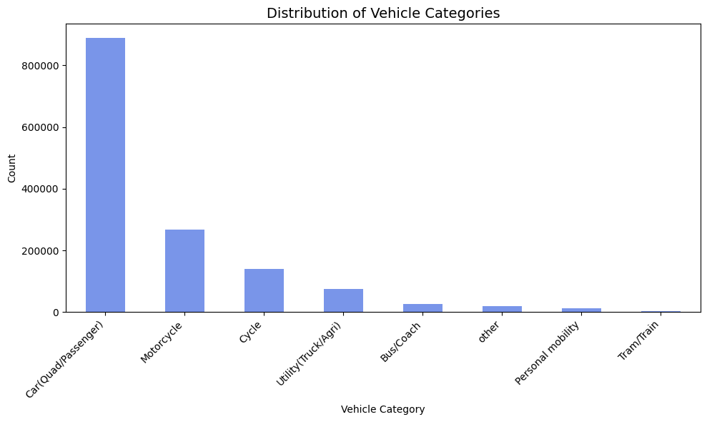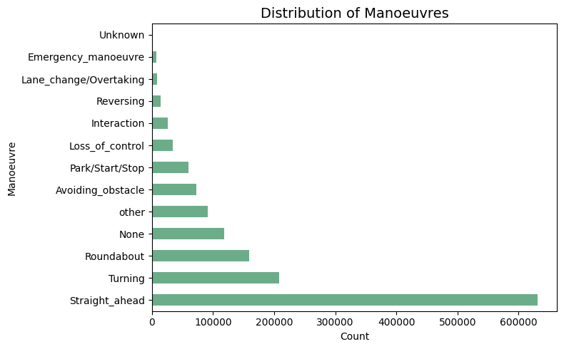
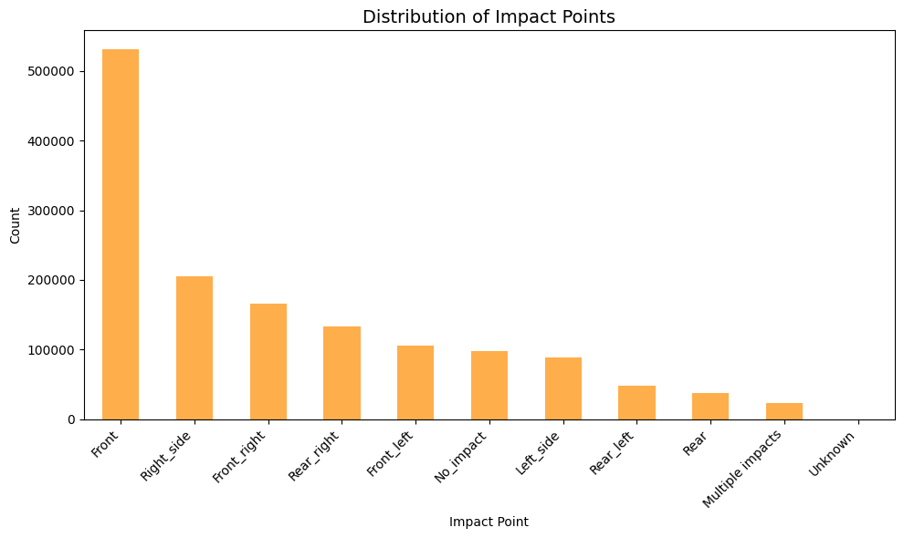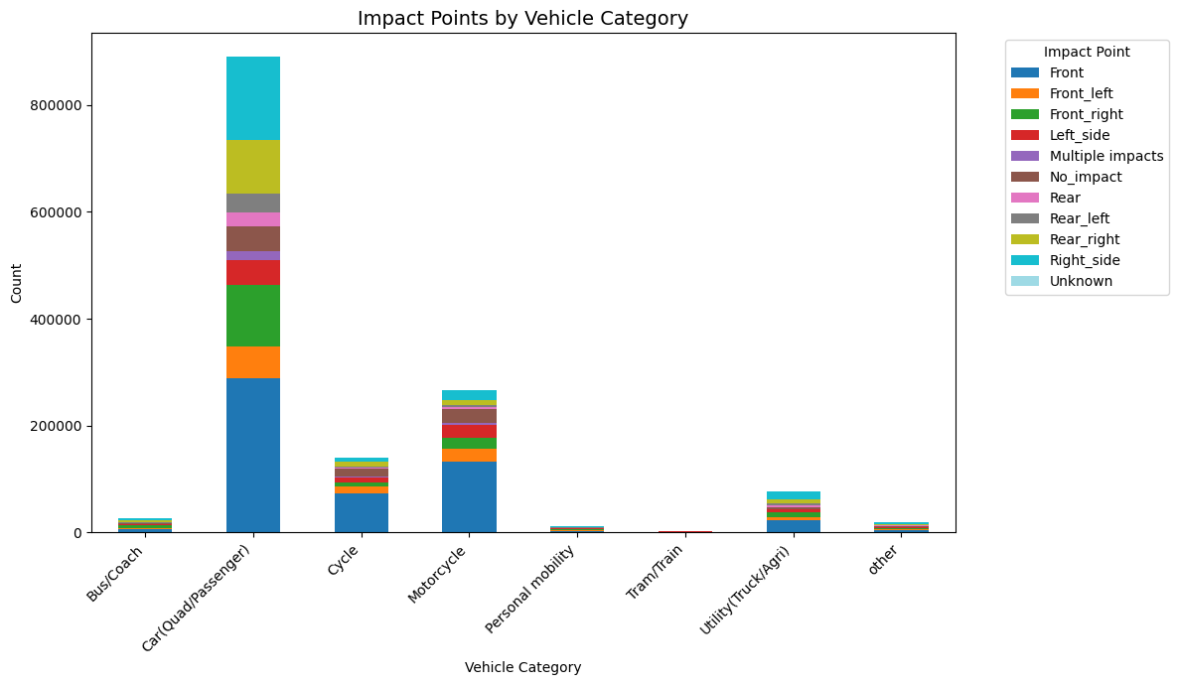

1. Vehicle Category Distribution
- Passenger cars dominate accident involvement
- Motorcycles and cycles form a significant secondary group
- Utility, bus, and personal mobility devices are present but less frequent

2. Manoeuvre Distribution
- Straight-ahead driving is most common before accidents
- Turning and roundabout maneuvers are also frequent
- Less common but critical: loss of control, lane changes, and emergency maneuvers

3. Impact Point Distribution
- Front impacts dominate, followed by side collisions
- Rear and multiple impacts are less frequent
- Suggests high exposure during forward motion and intersection navigation

4. Impact Points by Vehicle Category
- Cars show diverse impact profiles, especially front
- Motorcycles are disproportionately hit in the front
- Cycles and utility vehicles show varied patterns, reinforcing the need for tailored safety measures

Summary — Final Columns
After mapping and cleanup, you dropped all raw coded fields and kept only the interpretable, analysis-ready columns.

Dropped columns
- traffic_direction, vehicle_category, occupants
- fixed_obstacle, mobile_obstacle, impact_point, manoeuvre
- fixed_obstacle_label (redundant)

Final VEHICLES columns (8 total)
- accident_id
- vehicle_id
- traffic_direction_label
- vehicle_category_label
- mobile_obstacle_label
- impact_point_label
- manoeuvre_label
- occupants_group

Final shape - 1,433,389 rows × 8 columns

4.5 HOLIDAYS Dataframe —

Overview
The holidays dataframe contains official French public holidays across multiple years.
It is small, clean, and used to enrich accident records with a holiday indicator.

Cleaning & Preprocessing
- Renamed columns:
ds → date, holiday → holiday_name
- Converted date to proper datetime format
- Added a binary flag:
is_holiday = 1
- Removed duplicates based on date
- Cleaned holiday names (trimmed whitespace, filled missing with "None")

Final Shape
131 rows × 3 columns

Final Columns
- date — datetime holiday date
- holiday_name — cleaned holiday label
- is_holiday — indicator (always 1)

MASTER DATAFRAME MERGE -(ACC)

Final Cleaning • Merge Logic • Integrity Checks • Interpretation

5.1. Pre-Merge Validation
Before merging, all key dataframes were checked for structural consistency.

1.1 Key Column Types
Dataframe | accident_id dtype | date dtype
CARACT | int64 | datetime64
PLACES | int64 | —
VEHICLES | int64 | —
USERS | int64 | —
HOLIDAYS | — | datetime64
Result:
✔ All accident_id columns share the same type
✔ All date columns are proper datetime objects
✔ Safe to merge

5.1.2 Duplicate Key Removal
Dataframe | Key | Action
CARACT | accident_id | Drop duplicates
PLACES | accident_id | Drop duplicates
VEHICLES | accident_id + vehicle_id | Drop duplicates
USERS | accident_id + vehicle_id | Drop duplicates
HOLIDAYS | date | Drop duplicates
Result:
✔ All tables contain unique keys
✔ No accidental row inflation before merge

5.1.3 Missing Values in Keys
Key | Missing Count
accident_id (all dfs) | 0
vehicle_id (vehicles/users) | 0
date (caract/holidays) | 0
Result:
✔ No missing join keys
✔ Merge will not lose or misalign rows

5.2. Merge Pipeline
The merge was executed in five controlled steps, preserving granularity.

Step 1 — Accident-Level Base
acc = caract.copy()

Step 2 — Add Road/Place Characteristics
acc = acc.merge(places, on="accident_id", how="left")

Step 3 — Add Vehicle-Level Information
acc = acc.merge(vehicles, on="accident_id", how="left")

Step 4 — Add User-Level Information
acc = acc.merge(users, on=["accident_id", "vehicle_id"], how="left")

Step 5 — Add Holiday Information
acc = acc.merge(holidays, on="date", how="left")

Post-Merge Holiday Cleanup
is_holiday → fillna(0)
holiday_name → fillna("Not a holiday")

5.3. Final Master Dataframe (ACC)

Shape
1,433,389 rows × 52 columns

Granularity
One row = one user in one vehicle in one accident
This is the most detailed level of analysis.

5.4. Post-Merge Integrity Checks

5.4.1 Duplicate Accident IDs
593,404 duplicates
Interpretation:
Expected and correct.
- One accident → multiple vehicles
- One vehicle → multiple users
- Therefore: accident rows expand during merge
✔ No issue
✔ Confirms correct relational structure

5.4.2 Missing Values in Key Columns
Column | Missing
accident_id | 0
date | 0
vehicle_id | 0
✔ All keys preserved
✔ No merge failures
✔ No orphaned rows

5.4.3 Holiday Flag Distribution
is_holiday | Count | Percent
0 (non-holiday) | 1,403,380 | 98%
1 (holiday) | 30,009 | 2%
Interpretation:
- Holidays represent a small but meaningful subset
- Useful for severity, frequency, and temporal pattern analysis

5.5. What the Results Mean

5.1 The Master ACC Dataset Is Correctly Structured
- Accident-level data (CARACT + PLACES)
- Expanded by vehicle-level data (VEHICLES)
- Further expanded by user-level data (USERS)
- Enriched with temporal context (HOLIDAYS)

5.2 Duplicate Accident IDs Are Expected
They reflect real-world relationships, not data errors.
5.3 Master dataframe ACC is:
✔ Clean
✔ Fully merged
✔ Structurally correct
✔ Free of key missing values
✔ Ready for both micro-level and macro-level analysis
This is a high-quality, Visualization-ready dataset.

6 . DATA VISUALIZATIONS

  - PHASE -1 - USER & VEHICLE CATEGORY

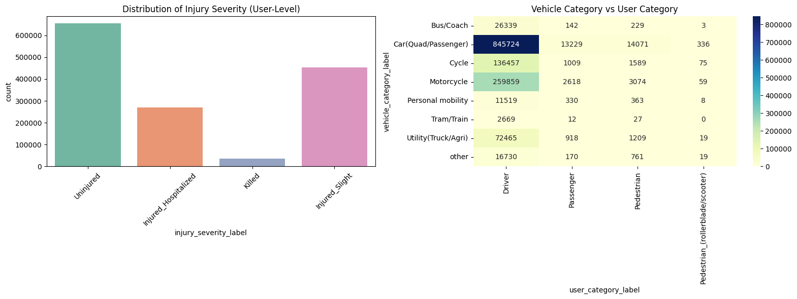
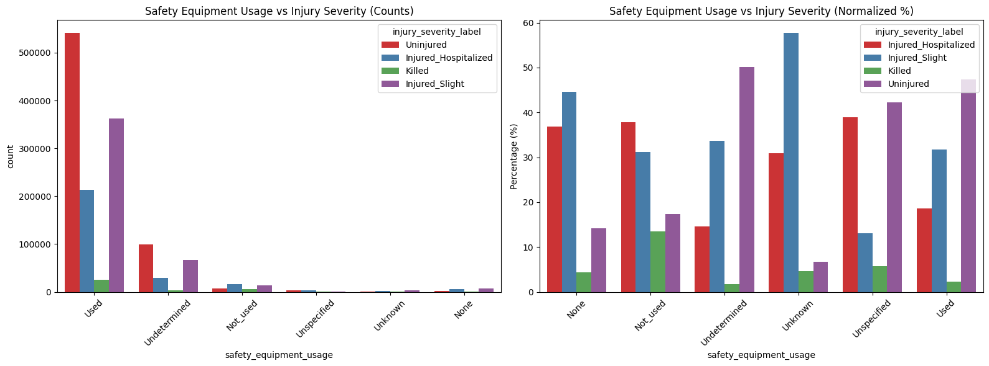
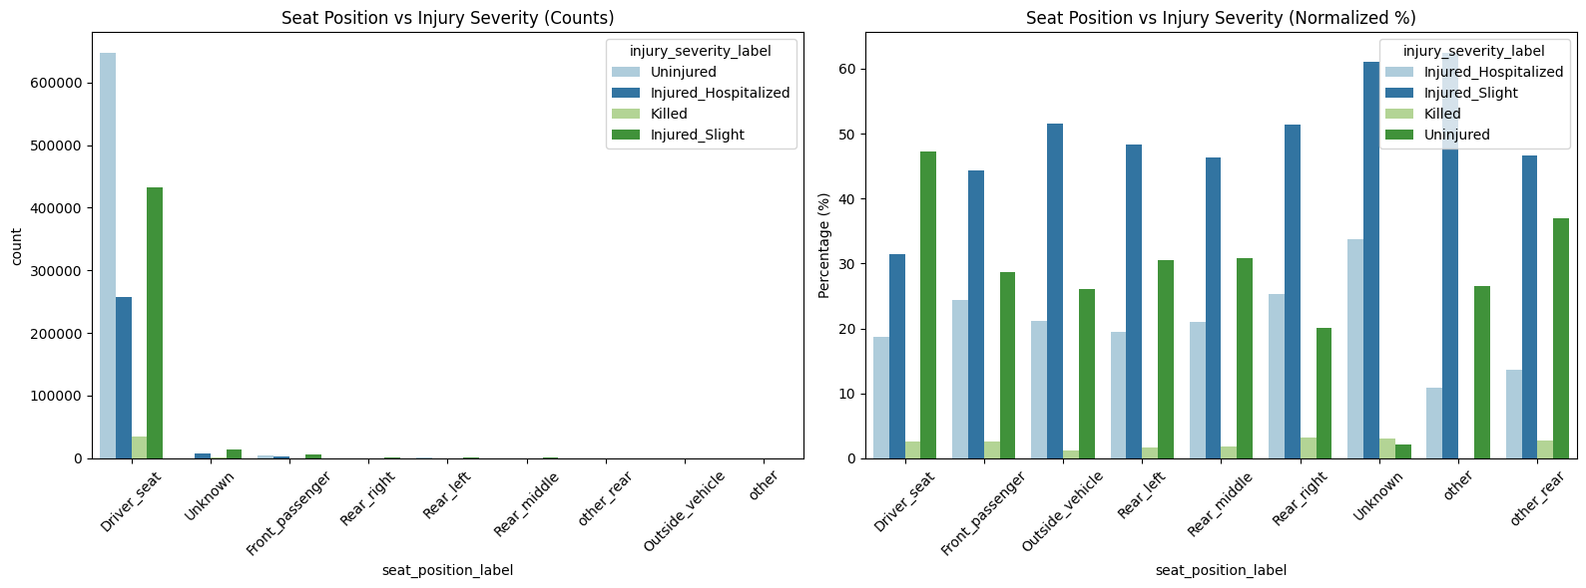

6.2 PHASE -2 - Accident Level Analysis
# Risk profiles by time and weather

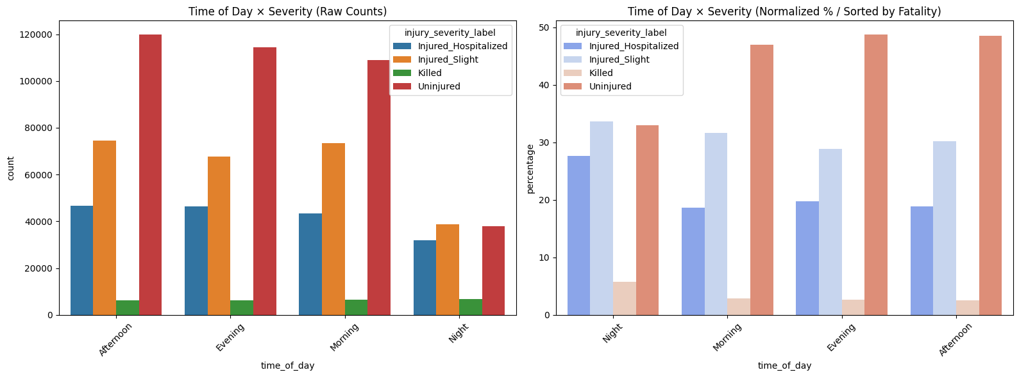
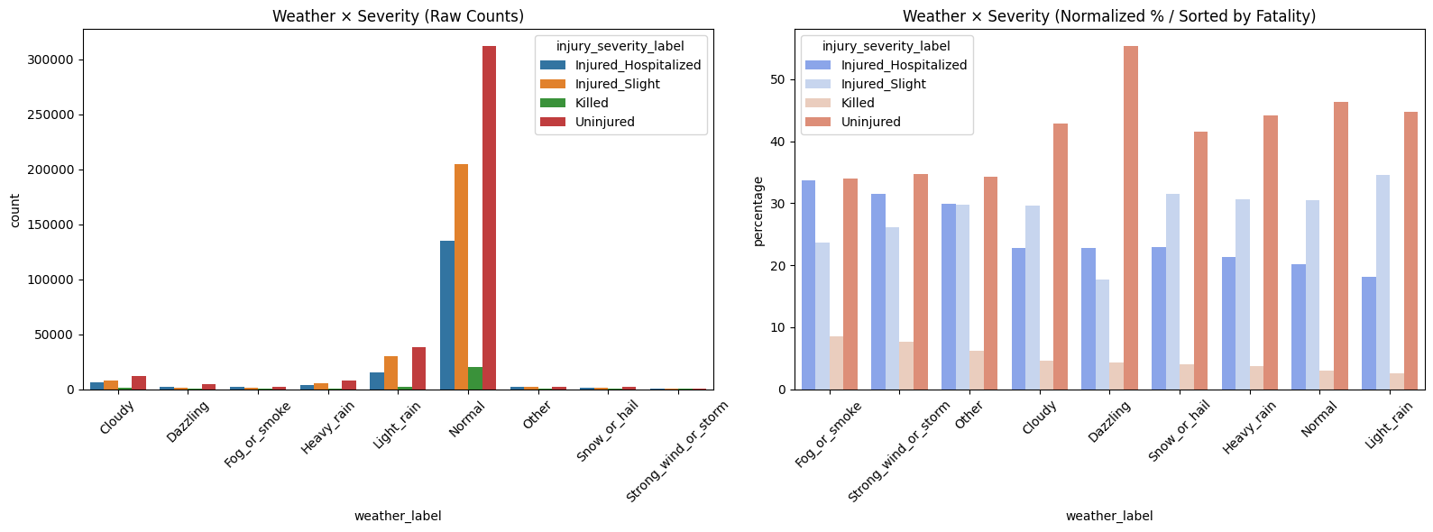

# Temporal Trends
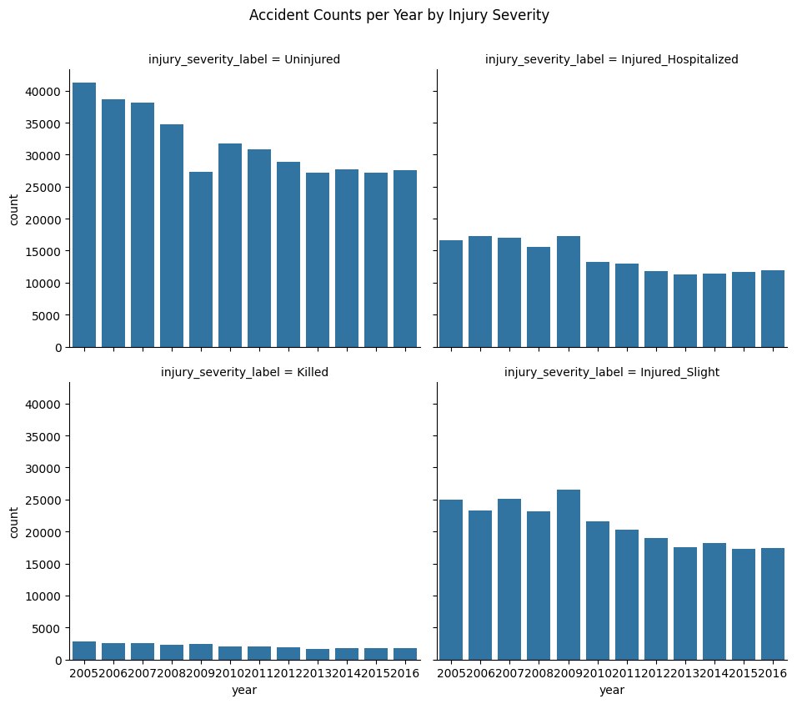
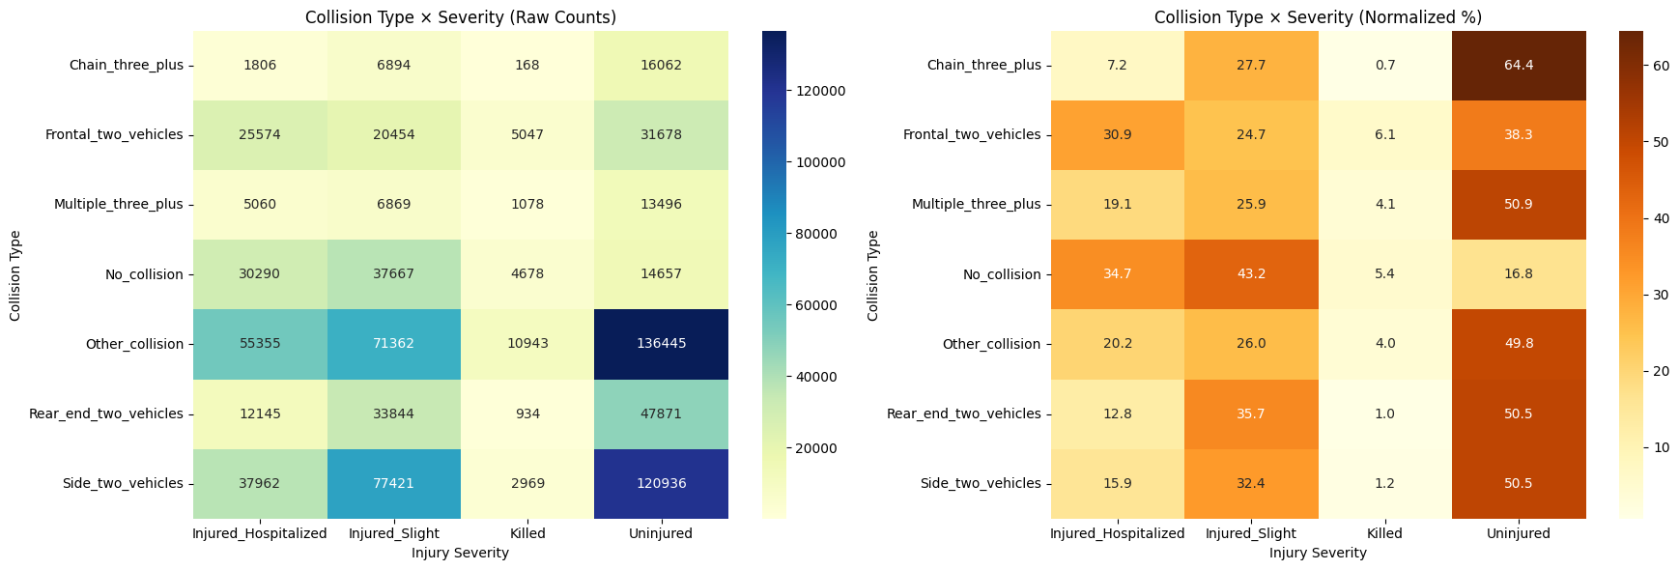
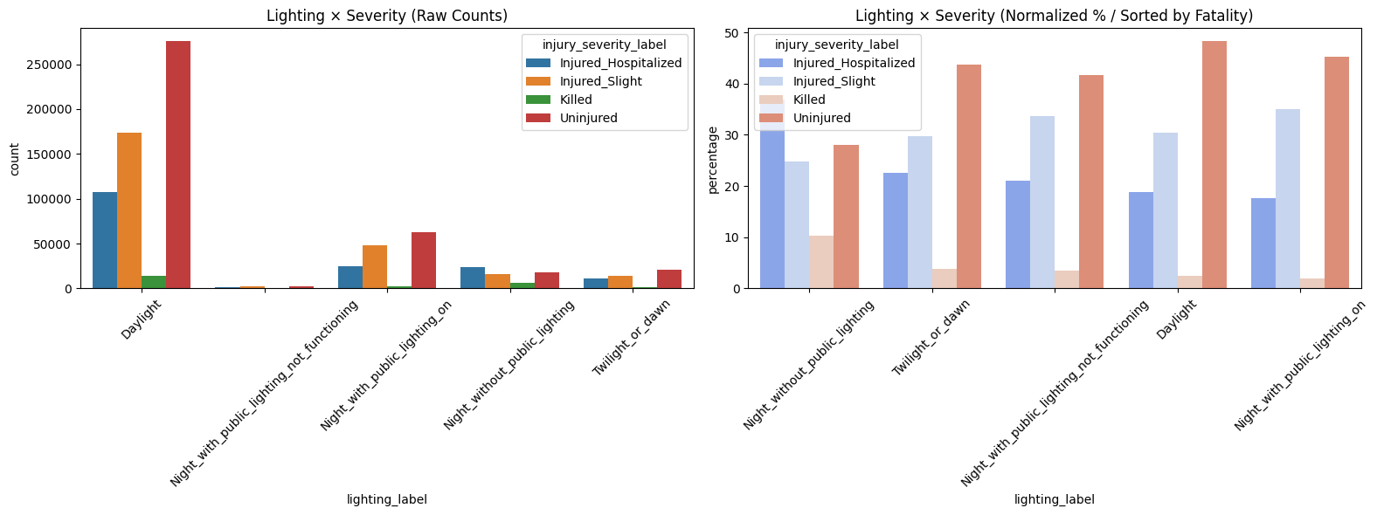

# Road & Infrastructure

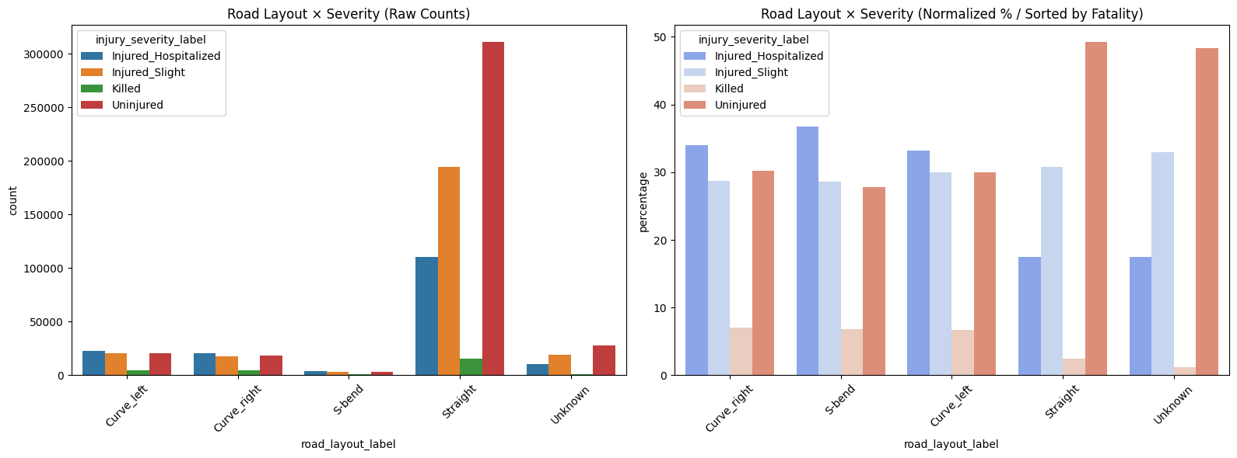
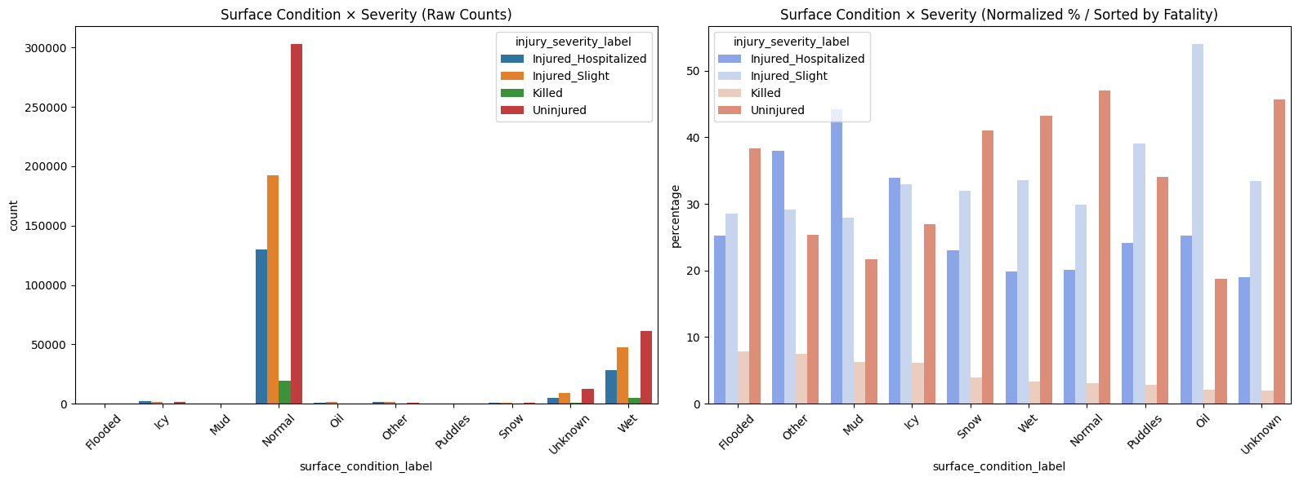
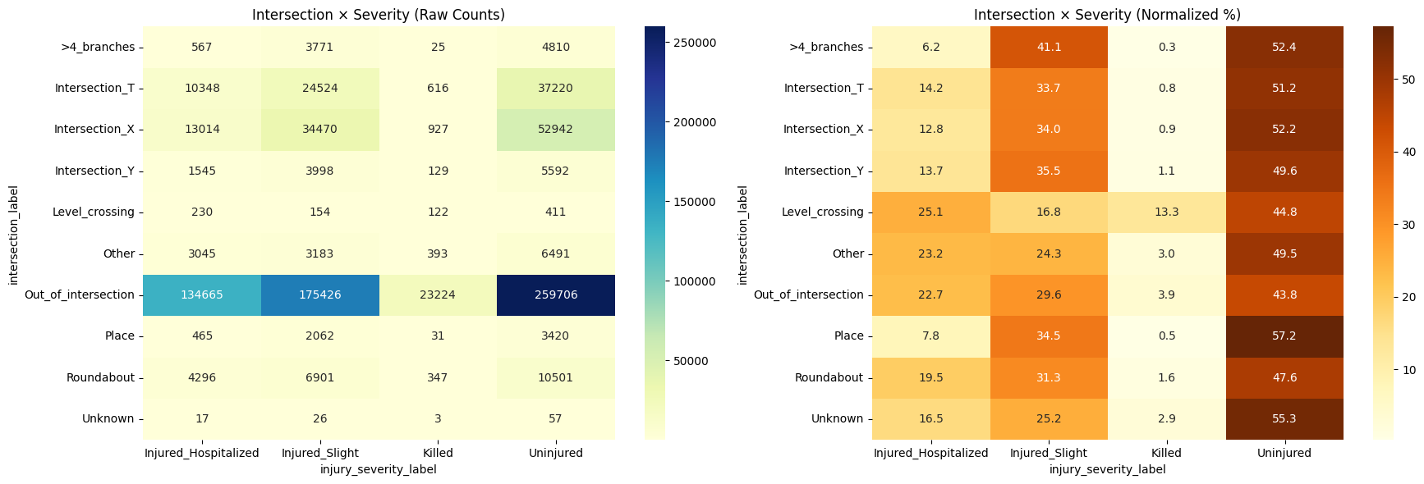

# Accident hour vs severity → distribution of accident times by severity

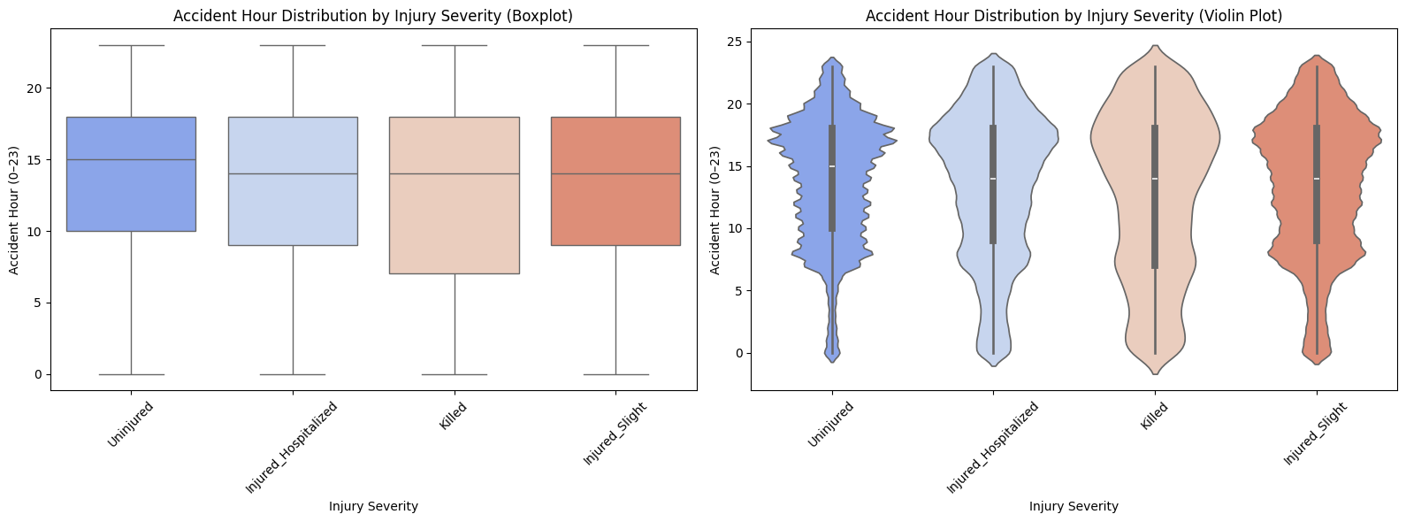
# fatal accident percentages by hour × lighting × weather

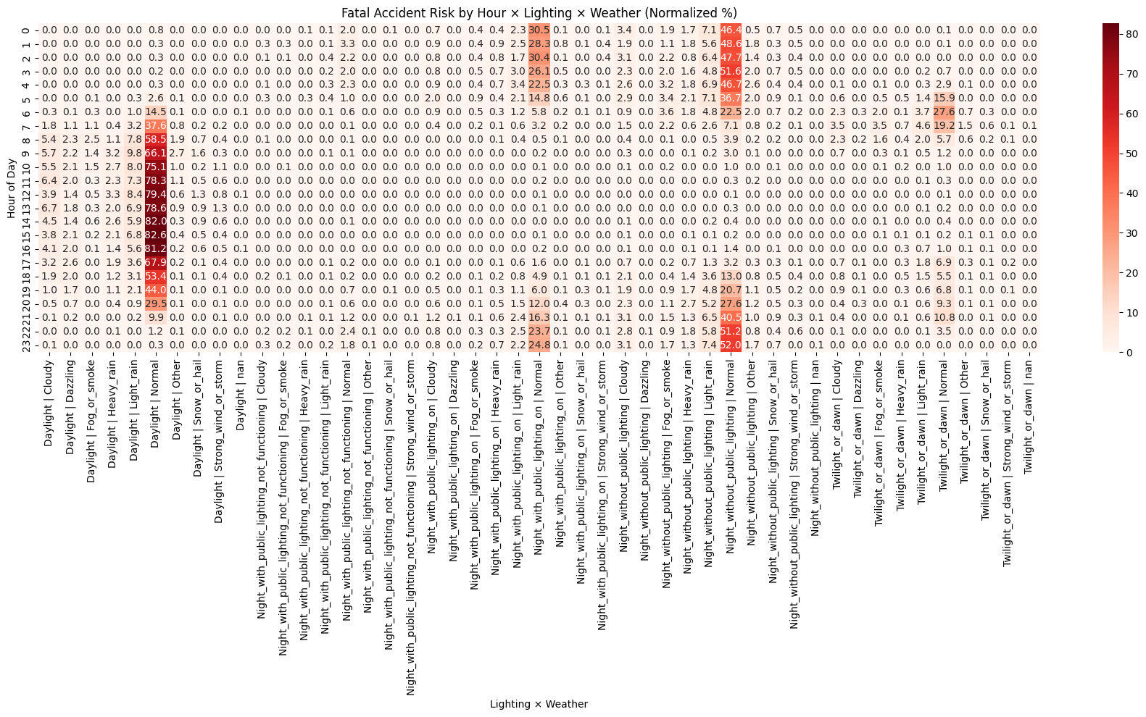

Notebook 2 - Data Preprocessing and Feature Engineering

Initial Data Audit

1.1. Dataset Loaded Successfully
The master dataset acc.csv has been imported with:
- 1,433,389 rows
- 53 columns

1.2. Structural Integrity

Column Types
- 37 categorical (object)
- 6 numeric floats
- 8 numeric integers
- 2 booleans
- 1 datetime-like column (date stored as object but convertible)

Duplicate Rows - 0 duplicates

1.3. Missing Data Overview
Most columns are complete, with missingness concentrated in expected areas:

Low Missingness (<0.01%)
- weather_label (92)
- collision_label (20)

Moderate Missingness (1–3%)
- Road geometry: num_lanes, road_width, pedestrian_crossing_width
- User attributes: birth_year, sex_label, injury_severity_label, etc.
- Safety equipment fields

High Missingness
- longitude_num (~74% missing)
- latitude_num (~74% missing)
These will require special handling (drop invalid geo rows or impute with centroids).

1.4. Descriptive Statistics (Numeric)
- Year range: 2005–2016
- Hour distribution: centered around 14:00
- Road width: mostly 0–80
- Birth years: mostly 1960–2000
- Holiday flag: ~2% of rows are holidays
All numeric fields fall within expected ranges.

1.5. Unique Value Audit
Every column was inspected:
- Keys (accident_id, vehicle_id) show correct cardinality
- Temporal fields (date, hour, time_of_day) are consistent
- Road attributes show realistic ranges
- User attributes show valid distributions
- Holiday names match the cleaned HOLIDAYS dataframe
✔ No anomalies
✔ No unexpected categories
✔ No corrupted values

2 . Data Cleaning & Preprocessing

1. Column Dropping & Index Setting

What was done
- Set accident_id as the dataframe index.
- Dropped 17 columns that were:
  - Redundant (Unnamed: 0, vehicle_id, date, minute, time_hhmm, gps_label, holiday_name)
  - Not useful for modeling (longitude_num, latitude_num, valid_geo)
  - Too sparse (mobile_obstacle_label, pedestrian_crossing_width, reserved_lane_label)
  - Dominated by a single category (pedestrian_location_label, pedestrian_action_label, pedestrian_state_label)

Why
- Reduces dimensionality
- Removes noise
- Improves model efficiency
- Eliminates columns with extremely skewed distributions or high missingness
Result:
Dataset reduced from 53 → 36 columns, keeping only meaningful predictors.

2.2. Type Casting

What was done
- Converted all label columns to category
- Converted numeric columns to compact numeric types (int16, int8, float32)
- Converted is_weekend and is_holiday to boolean

Why
- Memory optimization (critical for 1.4M rows)
- Faster model training
- Cleaner encoding for ML pipelines

2.3. Numeric Cleaning & Feature Engineering

2.3.1 Cleaning invalid numeric values
Rules applied:
Column | Invalid Values → NaN | Reason
num_lanes | ≤0 or >10 | Physical impossibility
road_width | ≤0 or >200 | Unrealistic road geometry
birth_year | <1900 or >2010 | Data entry errors

2.3.2 Age derivation
age = year – birth_year - Converted to float to preserve NaNs.

2.3.3 Age grouping
Created interpretable bins:
- Child
- Young_Adult
- Adult
- Middle_Aged
- Senior

Why
- Removes outliers
- Ensures realistic numeric ranges
- Adds age and age_group, which are strong predictors of injury severity
- Improves interpretability for modeling and reporting

2.4. Categorical Cleaning — Rare Category Grouping

What was done
- For every categorical column:
  - Calculated category frequency
  - Any category < 1% of rows was grouped into "other"

Why
- Prevents high-cardinality explosion during one-hot encoding
- Reduces noise from extremely rare categories
- Improves model generalization
- Stabilizes training for tree-based and linear models

Examples (after grouping)

vehicle_category_label
Category | Proportion
Car(Quad/Passenger) | 62.1%
Motorcycle | 18.6%
Cycle | 9.7%
Utility(Truck/Agri) | 5.3%
Bus/Coach | 1.9%
other | 2.3%

seat_position_label
Category | Proportion
Driver_seat | 97.1%
Unknown | 1.6%
other | 1.3%

intersection_label - Rare categories collapsed into "other".

3 — Feature Engineering
Feature engineering transforms raw accident records into meaningful, predictive features.
Below is a structured blend of tables and explanatory text, showing what was done and why it strengthens your modeling pipeline.

3.1. Safety Equipment Features
Safety equipment is one of the strongest determinants of injury severity.
The raw columns were multi-category and ambiguous, so we engineered clean binary indicators.

3.1.1 Engineered Safety Features
New Feature | Definition | Why It Was Created
seatbelt_used | Seat_belt + Used | Seatbelts drastically reduce injury severity; binary flag improves model clarity
helmet_used | Helmet + Used | Critical for motorcycle/bicycle injuries; isolates helmet behavior
any_protection_used | Any equipment marked “Used” | Captures general safety compliance
protection_effective | Used AND not Undetermined/Not_used | Removes ambiguous cases; isolates real protection

Why this matters
- Converts messy categorical combinations into clean, interpretable predictors
- Helps models learn the true effect of safety behavior
- Avoids mixing “Unknown” or “Undetermined” with real usage

2. Vehicle & Impact Features
Accident severity depends heavily on vehicle type, impact direction, and their interaction.

3.2.1 Vehicle Grouping
Original Category | New Group
Car(Quad/Passenger) | Car
Motorcycle | Motorcycle
Cycle | Bicycle
Utility(Truck/Agri) | Truck
Bus/Coach | Bus
Others | other

Why
- Reduces cardinality
- Improves model stability
- Reflects real-world risk differences (e.g., motorcycles vs cars)

3.2.2 Impact Grouping
Original Impact | Group
Front, Front_left, Front_right | Front
Rear, Rear_left, Rear_right | Rear
Left_side, Right_side | Side
Others | other

Why
- Direction of impact is a core determinant of injury severity
- Simplifies 11 categories into 4 meaningful groups

3.2.3 Interaction Feature
Feature | Logic | Why
motorcycle_side_impact | Motorcycle AND Side impact | Side impacts on motorcycles are extremely dangerous; this captures a high-risk scenario

3.3. Road & Accident Context Features
Environmental context shapes accident severity.
These engineered features capture lighting, road type, lane geometry, and weather.

3.3.1 Lighting & Urban Context
Feature | Logic | Why
is_night | True for any night lighting condition | Night accidents have higher severity due to visibility + speed
is_urban | True if Built_up_area | Urban vs rural environments differ in speed, density, and risk

3.3.2 Lane Geometry
Feature | Formula | Why
lane_width | road_width / num_lanes | Proxy for road class, speed, maneuvering space
Invalid or missing values were set to NaN.

3.3.3 Road Category Simplification
Original | Group
Highway | Highway
National_road, Departmental_road | Major_road
Communal_way | Local_road
Others | other

Why
- Road type strongly influences speed and severity
- Simplifies modeling and improves interpretability

3.3.4 Weather Grouping
Original | Group
Normal, Cloudy | Clear
Light_rain, Heavy_rain | Rain
Snow_or_hail | Snow
Fog_or_smoke | Fog
Dazzling, Strong_wind_or_storm, Other | other

Why
- Weather affects braking distance, visibility, and driver behavior
- Grouping reduces noise and improves model learning

3.4. Temporal Features
Human behavior changes by day, time, and season.
These features capture those patterns.

3.4.1 Date Reconstruction
Created from year–month–day.

3.4.2 Day of Week
Feature | Why
day_of_week | Weekends vs weekdays show different traffic patterns, speeds, and behaviors

3.4.3 Hour Group
Hour Range | Group
0–6 | Night
6–12 | Morning
12–18 | Afternoon
18–24 | Evening

Why
- Captures circadian patterns
- Reduces noise from 24 unique hour values

3.4.4 Weekend Flag
Feature | Logic | Why
is_weekend | Saturday or Sunday | Weekend accidents often involve leisure travel, higher speeds, and different demographics

Summary — Why This Feature Engineering Matters
Your engineered dataset now includes:
- Safety behavior indicators
- Vehicle and impact dynamics
- Road environment context
- Weather conditions
- Temporal behavior patterns
- High-risk interaction features
These transformations:
- Reduce noise
- Improve interpretability
- Capture real-world accident mechanics
- Strengthen model accuracy and generalization
- Embed domain knowledge directly into the dataset
This is exactly the kind of feature engineering that turns raw data into predictive power.

4 — FINAL Pruning

Why each column was removed before modeling
After feature engineering, many raw columns became redundant, noisy, or harmful for modeling.
Pruning reduces dimensionality, improves model stability, and prevents leakage or multicollinearity.
Below is a category-wise explanation of every dropped column and the reasoning behind it.

4.1. Safety Equipment Columns (Replaced by Engineered Flags)
Dropped Column | Why It Was Removed
safety_equipment_type | Replaced by seatbelt_used, helmet_used, any_protection_used, protection_effective
safety_equipment_usage | Raw categories were ambiguous (“Undetermined”, “Unknown”); engineered flags capture true behavior
Reason:
The engineered binary features are cleaner, more predictive, and avoid category noise.

4.2. Vehicle & Impact Columns (Replaced by Grouped Features)
Dropped Column | Why It Was Removed
vehicle_category_label | Replaced by vehicle_group (Car, Motorcycle, Bicycle, Truck, Bus, other)
impact_point_label | Replaced by impact_group (Front, Side, Rear, other)
Reason:
Grouped features reduce cardinality, improve interpretability, and capture physics of collisions better.

4.3. Road Context Columns (Replaced by Simplified Groups)
Dropped Column | Why It Was Removed
lighting_label | Replaced by is_night
urban_label | Replaced by is_urban
road_category_label | Replaced by road_group
weather_label | Replaced by weather_group
Reason:
Raw categories were too granular; grouped features capture the meaningful environmental patterns.

4.4. Temporal Columns (Replaced by Engineered Time Features)
Dropped Column | Why It Was Removed
year, month, day | Reconstructed into date, then into day_of_week, season, is_weekend
hour | Replaced by hour_group
time_of_day | Redundant after hour_group + is_night
date | Replaced by richer temporal features
Reason:
Engineered temporal features capture behavioral patterns better than raw timestamps.

4.5. Demographic Columns (Replaced by Age Features)
Dropped Column | Why It Was Removed
birth_year | Replaced by age and age_group
Reason:
Age is more predictive and avoids unrealistic birth years.

4.6. Road Geometry Columns (Replaced by Lane Width)
Dropped Column | Why It Was Removed
num_lanes | Incorporated into lane_width
road_width | Incorporated into lane_width
Reason:
Lane width is a more meaningful geometric feature than raw lane count or road width alone.

4.7. Highly Imbalanced / Low-Information Columns
These columns had extreme skew (90%+ in one category) or provided almost no predictive value.
Dropped Column | Reason for Removal
infrastructure_label | ~89% “Unknown” → no signal
school_zone_label | Mostly “Not_near_school”; rare positives
occupants_group | ~99% “0” → no variance
situation_label | ~89% “On_road” → no useful separation
traffic_direction_label | ~92% “Same_direction”
intersection_label | Dominated by “Out_of_intersection”
traffic_regime_label | Mostly “Bidirectional”
road_profile_label | Mostly “Flat”
road_layout_label | Mostly “Straight”
Reason:
These features add noise, imbalance, and unnecessary dimensionality without improving prediction.

4.8. Final Result
After pruning:
- Columns reduced from 53 → 27
- All remaining features are:
  - Predictive
  - Interpretable
  - Balanced
  - Model-ready
Your final modeling dataset now contains:
- Safety behavior
- Vehicle & impact dynamics
- Road context
- Weather
- Temporal patterns
- Demographics (age)
- High-risk interaction features
This is a clean, compact, high-signal dataset optimized for machine learning.

Closing Statement
With this stage complete, the project now stands on a solid analytical foundation.
All raw accident, vehicle, user, road, and holiday datasets have been rigorously cleaned, merged, audited, and transformed into a unified, high-quality master dataset. Through systematic preprocessing and carefully designed feature engineering, we have reduced noise, corrected inconsistencies, simplified complex structures, and embedded domain knowledge directly into the data.
The resulting dataset is compact, interpretable, and rich in meaningful predictors — precisely the structure required for reliable modeling.
This concludes the full data preparation pipeline and positions us to move confidently into the next phase: model development, evaluation, and insight generation.

